Title: Large Scale Distributed Deep Networks
Publication venue/year: Large scale distributed deep networks. Advances in neural information processing systems. 2012
Why am I reading this paper (optional): Exploring different techniques and algorithms that could be used to scale up and out ML and DL.
Summary: In this paper, authors consider the problem of training a deep network with billions of parameters using tens of thousands of CPU cores by introducing a software framework called DistBelief (a framework for parallel distributed training of deep networks). Within the proposed framework, they also developed two algorithms for large-scale distributed training: Downpour SGD and Sandblaster L-BFGS. The use of these algorithms enhance both of scalability and speed of deep neural network training. Authors discovered that, while Downpour SGD works well for training nonconvex deep learning models. Sandblaster L-BFGS is better as it saves network bandwidth which allows to scale to larger number of concurrent cores for training a single model. Nevertheless, the combination of Downpour SGD with Adagrad adaptive learning rate achieves higher accuracy than Sandblaster when working with a computational budget of 2000 CPU cores or less.
Research Problem Addressed:
The scale of deep learning, with respect to the number of training examples, the number of model parameters, or both can exceedingly improve classification accuracy,. This results to look for scaling up the training and inference algorithms utilized by models. The use of GPU has proven its efficiency when the model can fit in the GPU memory, but it will be a limitation to use GPU when the model is larger than GPU memory. To face this limitation, many researchers tried to reduce the size of the data parameters. This may work for small problems, but for larger number of examples and dimensions it will be hard.
Proposed solution: Google propose using large-scale clusters of machines to distribute training and inference in deep networks. They developed DistBelief framework which allows parallelization with machine (by multithreading) and across machine (by message passing). DistBelief supports data parallelism, where multiple replicas of model are used to optimize a single objective. Within DistBelief authors designed and implemented two novel methods for large-scale distributed training: (i) Downpour SGD, an asynchronous stochastic gradient descent procedure which leverages adaptive learning rates and supports a large number of model replicas, and (ii) Sandblaster L-BFGS, a distributed implementation of L-BFGS that uses both data and model parallelism. Both Downpour SGD and Sandblaster L-BFGS enjoy significant speed gains compared to more conventional implementations of SGD and L-BFGS.

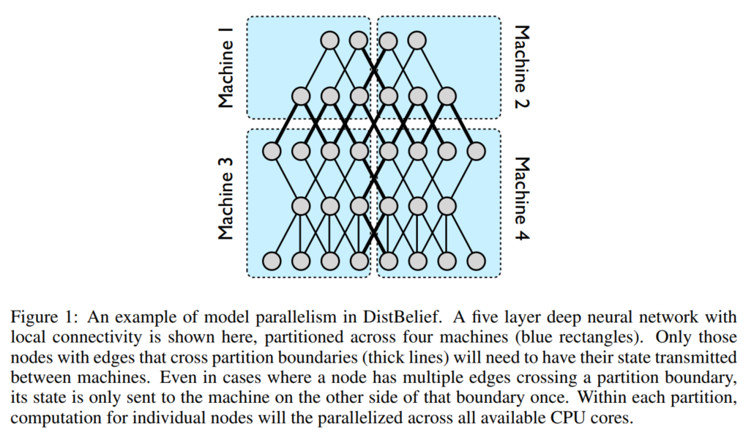

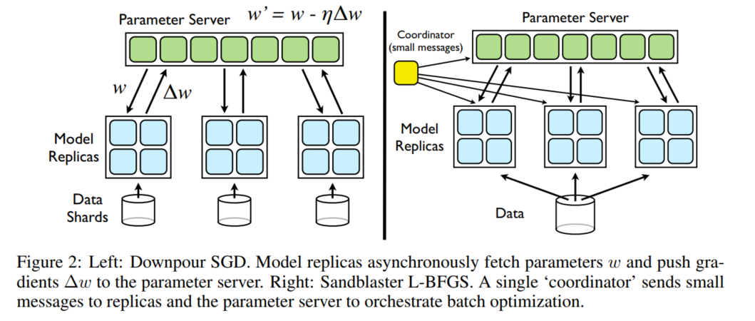

Your comments:
Strong points:

- They have proven through experimentation that Sandblaster L-BFGS and Downpour SGD with Adagrad can train models substantially faster than a high performance GPU.
- The Sandblaster L-BFGS system does show promise in terms of its scaling with additional cores, suggesting that it may ultimately produce the fastest training times if used with an extremely large resource budget (e.g., 30k cores).

Weak points:

Next steps: I will search for the common implementation of SGD on TensorFlow. Also, I will read more about minibatch SGD and tries to implement it using TensorFlow. I will search the adaptive learning rate techniques that could be used as a combination with SGD such as Adadelta.

